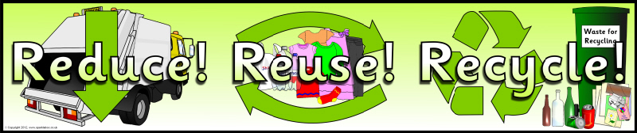
Burr Elementary Goes Green
Slogan and Poster Contest Rules

- This contest is open to BES students in all grades.

- Create a poster design with an original slogan (a catchy saying you thought up yourself) that you design by hand (not on a computer) can be used to promote waste reduction at BES.
- Your entry should be on 8.5” x 11” paper. You do not need to use a large poster board. Be certain that your name is on the back of your design!
- Entries are due on Monday, November 30, 2015. Turn your design into your teacher by the end of school that day.
- The winning entry will be announced on Friday, December 4th and will be used to promote recycling and waste reduction at Burr School.
Good luck!

