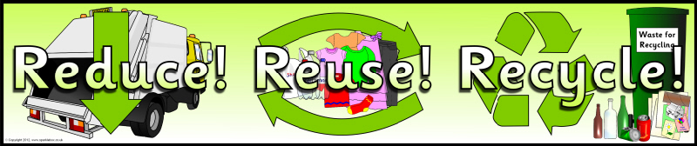
Application
Waste Management Ambassador
Burr Elementary Grades 2, 3 and 4

Name: ____________________ Grade: _____

Classroom Teacher: __________ Room: _____

Tell about your interest in reducing waste at Burr and your leadership qualities (why you would be a good choice to inform kids about waste management):
________________________________________________________________________________________________________________________________________________________________________________________________________________________________________________________________________________________________________________________________
Explain some ideas you have to make changes that would make BES more “green” (for example, ideas for reducing waste, saving energy, or becoming better at recycling): ________________________________________________________________________________________________________________________________________________________________________________________________________________________________________________________________________________________________

I understand that this position will require me to attend Waste Management ambassador meetings and to write about and speak to my grade about waste management.

Signed (student) ___________________________
Parent Signature: __________________________
Date: ______________________

